Module 06 – Transshipment Problem

Exploratory Data Analysis

*In this section, you should perform some data analysis on the data provided to you. Please format your findings in a visually pleasing way and please be sure to include these cuts:*

* *Make a visual graph of your data like what we saw for the sample problem*
  + <https://excalidraw.com>
  + <https://mermaid.live>
  + <https://dreampuf.github.io/GraphvizOnline>
  + Powerpoint

Model Formulation

*Write the formulation of the model into here prior to implementing it in your Excel model. Be explicit with the definition of the decision variables, objective function, and constraints.*

*Hint: This one differs a bit from the sample problem in terms of Balance-of-Flow*

MIN=X08+X13+X18+X28+X34+X35+X36+X37+X38+X43+X46+X65+X83+X84

Model Optimized for Minimal Transportation Cost

*Implement your formulation into Excel and be sure to make it neat. This section should include:*

* *A screenshot of your optimized final model (formatted nicely, of course)A screenshot of a computer

  AI-generated content may be incorrect.*
* *A text explanation of what your model is recommending.*
* *Update your graph from the EDA section to bold/color the links being used (and show how much is going through that link)*

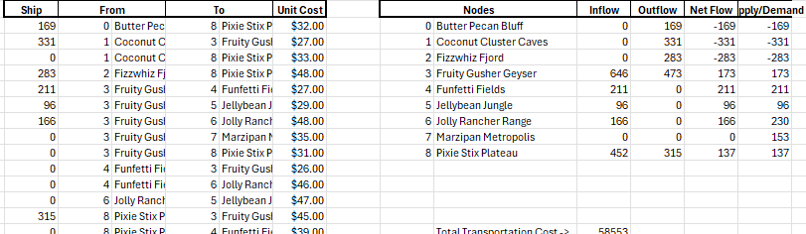

Recommending to decrease the supply

Model with Stipulation

*Please copy the tab of your original model before continuing with the next part to avoid messing up your original solution.*

*Follow these steps to complete this section:*

1. *Describe the necessity of the Balance-of-Flow for this problem type*
2. *What happens when you change your model to make Total Supply > Total Demand (i.e. add 115 units to one of the sources) The total transportation cost goes down by about 12,000*
3. *What happens when you rerun your model? The data updates for everything across the model.*
4. *What do you need to change to make your model work again? Make demand equal or greater than supply*
5. *Make the changes and report on your findings.*
   1. *PS there is a small chance that the source you added 115 to may make your model infeasible. If so, add the 115 units to a different source.*

*It makes the total transportation cost go back up*

*I switched it back so that demand is greater than supply and costs are back up higher than originally.*